**Arcade**

**Car**

**Controller**

**Multiplayer**

**(ACC)**

|  |  |
| --- | --- |
| **C:\Users\User\AppData\Local\Microsoft\Windows\INetCache\Content.Word\Logo.png** | **Perfect Games** |

**Contents**

Introduction 3

Code style 4

Multiplayer 5

Matchmaking 6

In game 8

Simplified WheelCollider setup 11

Regime Settings 13

How to create car 17

How to debug 19

Car settings 20

AI Control 25

Balance settings 27

Split level loading 28

How to create a track 29

Positioning System 32

Main menu and game menu. 34

In race UI 37

Shader: AlphaColorMask 39

Mesh Painter 40

Update history. 42

Contacts 45

# Introduction

First of all, I want to thank you for purchasing this asset, you are helping me to improve. And sorry for my bad English, i'm learning it.

The primary objective of this project is an easy arcade control, while not losing the feeling of a controlled machine.

The project is being developed for weak devices, so I try to optimize the code, use as few materials as possible, use more compressed textures, use polygon saving.

If you find a bug or have any suggestions, please let me know, the contacts are listed at the end of this document.

I also have a small request for you: If you like an asset, please write a review on the AssetStore page, it helps a lot in promoting and motivating me to improve and add content.

# Code style

Private and public fields or properties belonging to the class begin with a capital letter:







In the event that a variable has a property, the variable begins with a small letter, the property with a large.





Parameters of the method and variables declared in the body of the method begin with a small letter.

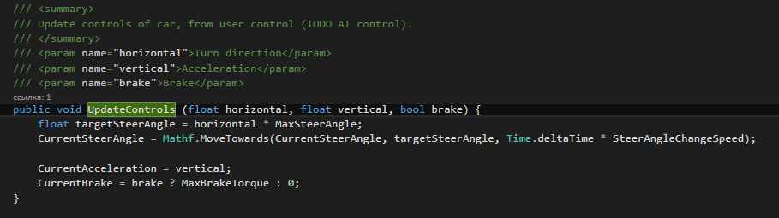

All fields, properties and method names are chosen to maximize the destination.

# Multiplayer

!!!Attention!!!

Project setup, first you need to download and import “PUN2 – free” asset <https://assetstore.unity.com/packages/tools/network/pun-2-free-119922>,

Then you need to login or register at <https://www.photonengine.com/>.

In the profile, click the "Create A new APP" button.

In the form indicate:

"Photon Type" - Photon PUN,

"Name" - The name of your application.

On the application page, you need to copy the “App ID” and paste it into the PhotonServerSettings asset, field "App Id Realtime" in the Unity project.

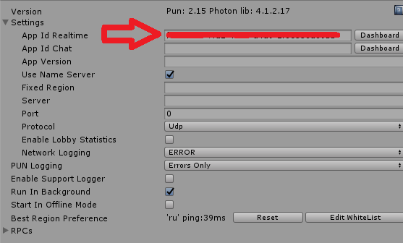

After completing the steps, you need to re-import the "Multiplayer Arcade Car Controller: Drift". Done, the project is ready to play.

For all questions arising when connecting a photon, you can contact me in any convenient way. I will gladly help you.

## Matchmaking

All matchmaking logic is in the main menu.

Room list window:

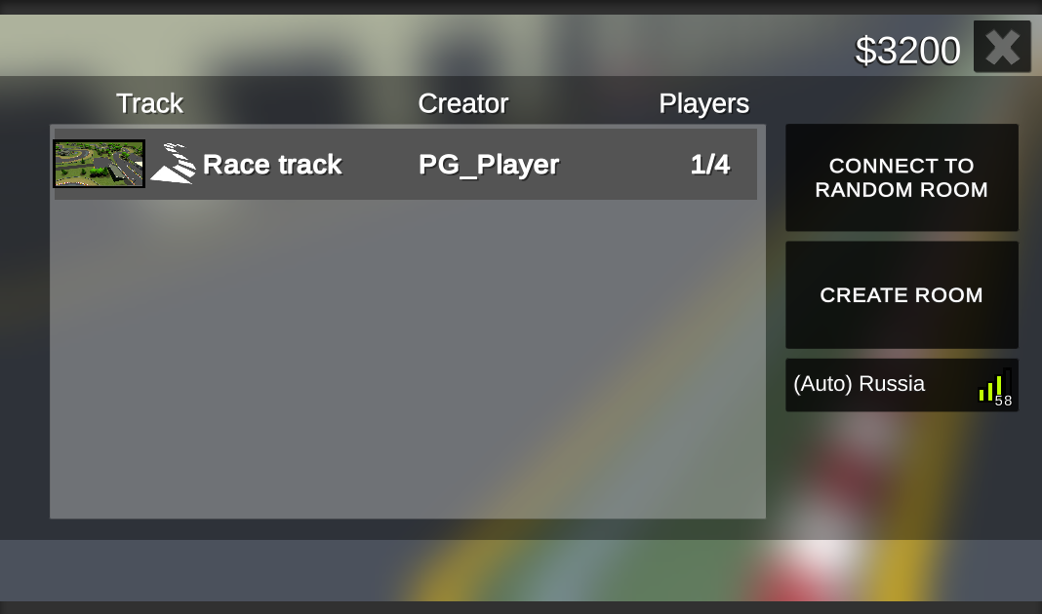

The window contains information about access rooms.

Button "Create room" - creates a room accessible to other players, before the start of the game, the room will be open for connection.

Button "Connect to random room" -

connect to a random open room, if there are none, a room will be created. Important! Manually created rooms are not taken into account, these are 2 different types of machmeikig.

Servers drop down - indicates the status of the current connection (Server and ping). By default, the best server is selected. Players from different servers cannot play with each other and do not see rooms from other servers.

The buttons is inactive if there is no connection to the photon. To connect to the room you need to click on it.

Important! For multiplayer cars are selected from the list "MultiplayerSettings/AvailableCarsForMultiplayer" regardless of the regime selected, this is done because of the ability to select a car after selecting a track.

In room window: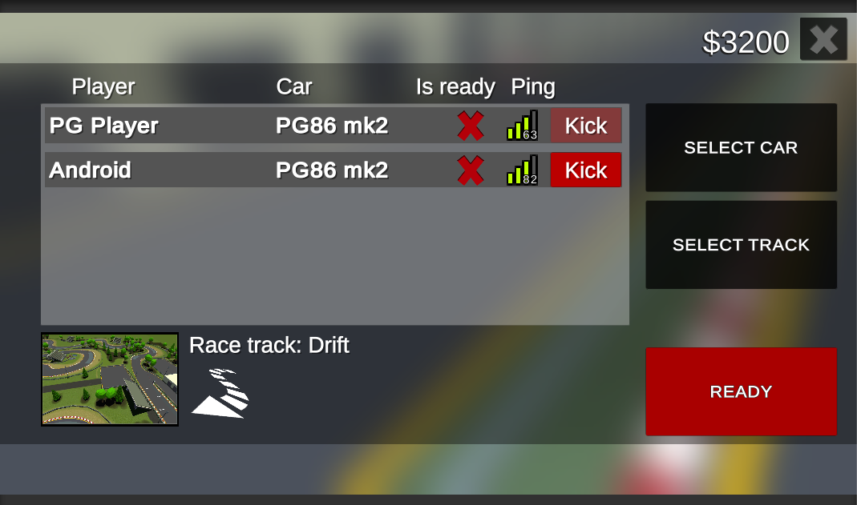

The window contains information about connected players and the selected track. For all players available buttons select the car and "Ready". A track selection button is available for the master. Also, the master can expel players from the room by pressing the "Kick" button.

In random room window:

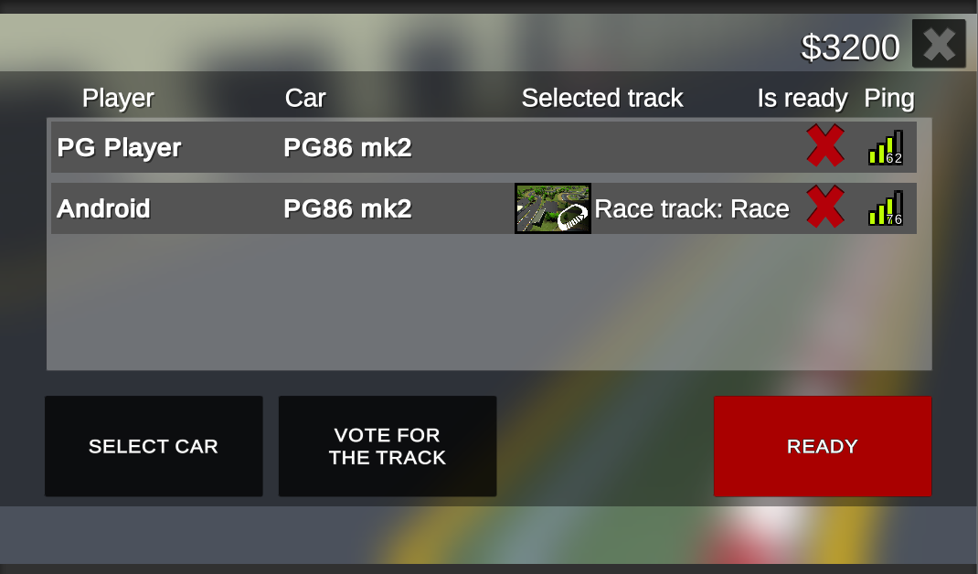

Each player can select a track, the track for which there will be the most votes will be launched. If no one selects a track, then randomly starts. Since there is no room creator, players cannot be kicked out. After the completion of the race, all players return to the "In random room" window, and the room opens to connect new players.

## In game

For correct work, all car prefabs must have the "MultiplayerCarController" and "PhotonView" components. "PhotonView" in the list of "Observed Components" must indicate "MultiplayerCarController". All car prefabs should be located in the Resources folder.

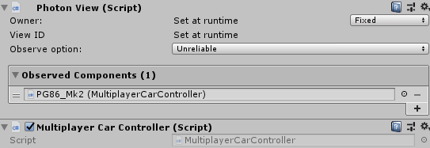

Multiplayer settings: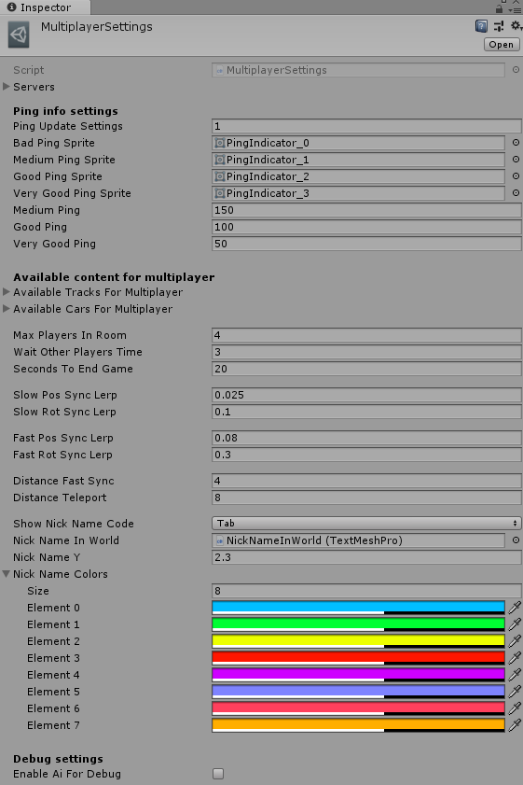

Servers - List of servers available for selection (Added all servers from the table <https://doc.photonengine.com/en-us/realtime/current/connection-and-authentication/regions>).

Ping info settings - Ping indicator display settings.

Max players in room - The name of the field speaks for itself.

Wait Other Players Time - Waiting after loading all the players for a synchronous start.

Seconds To End Game - Game end timer, activated when the first player finishes.

Slow Sync Speed - Synchronization speed when the car is in a radius (Distance Fast Sync) from the desired position.

Fast Sync Speed - Synchronization speed when the car is in a radius (Distance Teleport) from the desired position.

The car moves instantly if it is located outside the radius (Distance Teleport) from the desired position.

NickNameY - Height at which NIckName is located.

# Simplified WheelCollider setup

PG_WheelCollider.cs

By popular demand, I created this class. Now the collider slide can be adjusted from 0 (Low Friction) to 1 (High Friction).

All values are duplicated from the standard wheel collider.

For correct editing, you need to edit the PG_WheelCollider.

Also, using this class, it is easy to change the parameters of the collider at runtime. See the section on “Regime Settings” for more details.

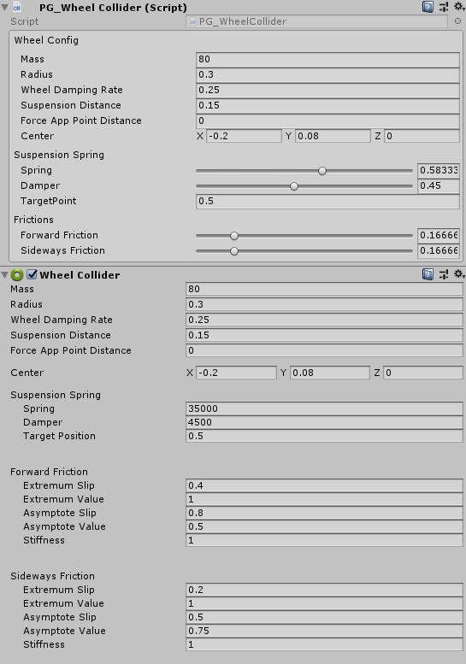

If you are not satisfied with the minimum or maximum values, you can change them in the class PG_WheelCollider: Minimum and Maximum friction constants.

PG_WheelCollider this class uses the PG_WheelColliderConfig structure with attribute [FullField].



With this attribute, the field is fully displayed.

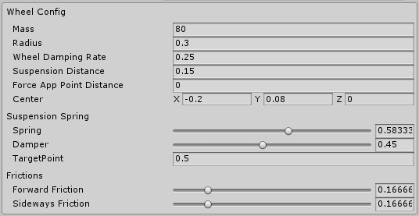

The structure is used in the mode settings without the [FullField] attribute and the IsFullConfig switch turned off. To transfer only friction parameters to the wheels.

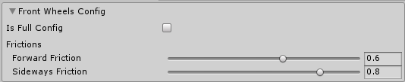

If you turn on the IsFullConfig switch, then all the WheelCollider parameters will be transfer.

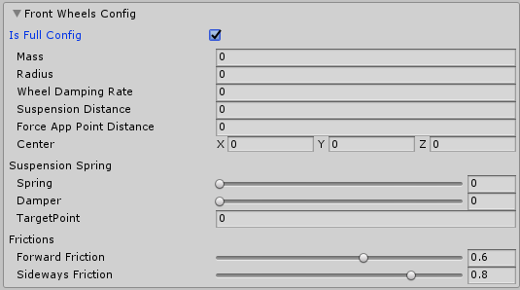

# Regime Settings

Now the game has two modes: Standard Racing and Drift. The drift has been greatly changed compared to the previous version of the asset (the machine behaves more dynamically). For those who liked the old version of the drift, I added a config with the settings "DriftRegimeSettings (OldVersion)" you need to select it in the track assets in the "RegimeSettings" field.

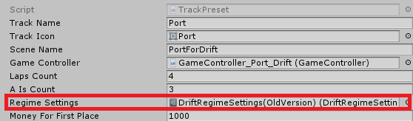

RegimeSettings fields.

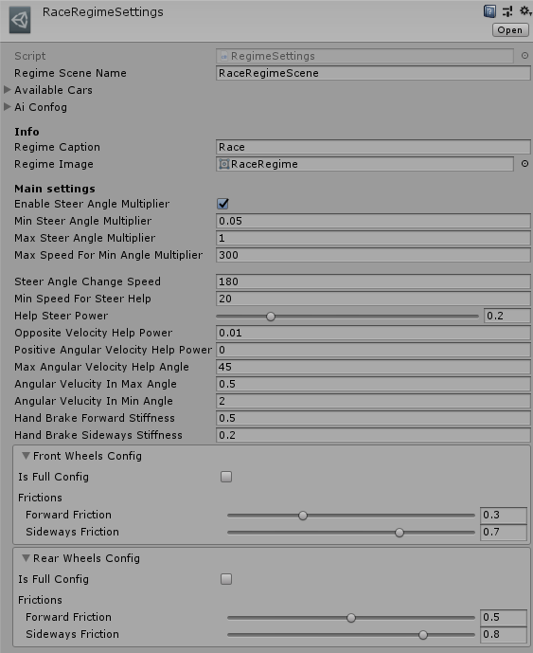

RegimeSceneName: The name of the scene for this regime.

AvailableCars: Cars available for this regime.

Important! For multiplayer cars are selected from the list "MultiplayerSettings/AvailableCarsForMultiplayer" regardless of the regime selected, this is done because of the ability to select a car after selecting a track.

AIConfig: AI configuration. For both regimes, one AI behavior with different parameters is used.

RegimeCaption, RegimeIcon: The name and icon of the regime to display in and in the UI.

**The following settings are also in CarController, for use separately from the regimes.**

EnableSteerAngleMultiplayer: Restricting steering at high speed.

MinSteerAngleMultiplayer: Minimum steering wheel multiplier. Achieved at maximum speed (MaxSpeedForMinAngleMultiplayer).

MinSteerAngleMultiplayer: Maximum steering wheel multiplier. Achieved at minimum speed (0).

MaxSpeedForMinAngleMultiplayer: The speed at which the maximum restriction of steering rotation is included.

SteerAngleChangeSpeed: The rate of change of the angle of rotation of the front wheels.

MinSpeedForSteerHelp: The speed at which management assistance is enabled.

HelpSteerPower: The power of help with side drift.

OppositeVelocityHelpPower: The force of additional rotation of the rigid body is used to stop the current drift.

PositioveAngularVelocityHelpPower: The force of the additional rotation of the solid is used to enhance the current drift.

AngularVelucityInMaxAngle: Max angular velocity, reached at max drift angles (For limit angular velocity).

AngularVelucityInMinAngle: Max angular velocity, reached at min drift angles (For limit angular velocity).

HandBrakeForwardStiffness: To change the friction of the rear wheels with a hand brake.

HandBrakeSidewaysStiffness: To change the friction of the rear wheels with a hand brake.

FrontWheelsConfig and RearWheelsConfig: The friction settings for the front and rear wheels are unique for each regime.

DriftRegimeSettings inherited from RegimeSettings has additional settings "Drift settings" they are needed to balance the calculation of drift score.

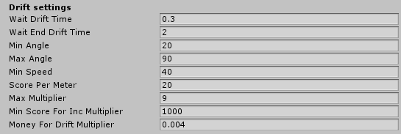

# How to create car

Auto add method ([Video instruction](https://youtu.be/OYYRnbhg8mE)):

The car can be easily added using the window "Window/Arcade Car Controller (ACC)/Create car"

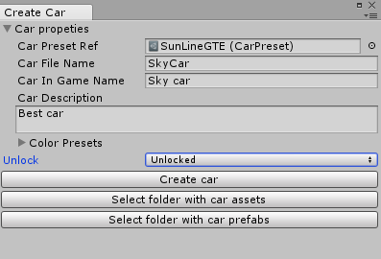

CarPresetRef: Asset of the car for copying prefab. It’s easier to change an existing prefab than create a new one.

CarFileName: All car files will be created with this name.

CarInGameName: The name of the car that will be displayed in the game (Menu).

Unlock: A way to unlock a car.

After setting all the parameters, you need to click the "Create car" button, after which all the necessary files will be created. After creating the car, you can edit the prefab (Change the view, change the configuration).

"Select folder ..." buttons are needed to search for folders in which files are created.

All default settings and file saving paths are in the CreateHelperSettings asset.

Manual way to add ([Video instruction](https://youtu.be/jqjjRdsX1NM)):

In order for the car to be selected in the selection menu you need to create:

The prefab of the car for the game (the process is specified in the CarSettings section).

For menu you can use the main prefab with the car, or you can create a separate prefab (More detailed) separately for the menu with the CarInSelectMenuPrefab component (To select a color).

Asset CarPreset with links to prefabs, a description of the car and the available colors.

CarPreset have unlock logic, field “Lock Type”.

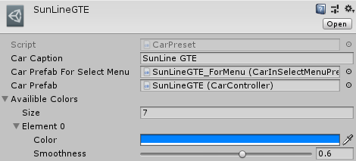

!!!Attention!!! Color selection is only available for cars with a AlphaColorMask shader.

For convenience, you can duplicate the existing prefabs and assets.

The link to the created asset should be placed in lists "GameController/CarsForThisRegime" and "MultiplayerSettings/AvailableCarsForMultiplayer". (For some reason, many users do not notice this text :))

# How to debug

To quickly launch a track scene (in debug mode) with a player’s car you to need Place the car prefab with the “CarController” component on the scene in the right place for you, then start the scene.

To check the AI, you need to add the "DriftAIControl" component to the car on the scene.

The regime for debug is selected in GameController / RegimeForDebug.

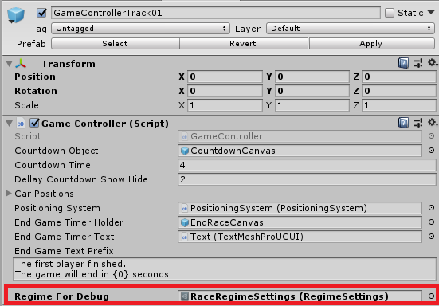

# Car settings

The physics of the car is based on standard WheelColliders.

WheelColliders config:

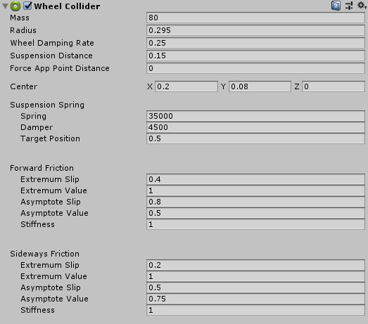

Wheel collider settings can be duplicated from existing cars, friction settings are loaded at the start of the level from WorldLoading.RegimeSettings.FrontWheelsConfig and RearWheelsConfig.

CarController.cs: Main gameplay class.

All car settings can be used in any genre (Not only drift).

In the fields of the wheel type is configured: links to, WheelCollider, wheel view, and the value of the slip at which particles are emitted.

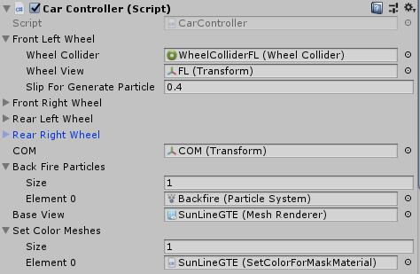

COM: Center of mass.

BackFire: BackFire emitters.

SetColorMeshes: All painted parts in selected color (Only for AlphaColorMask shader).

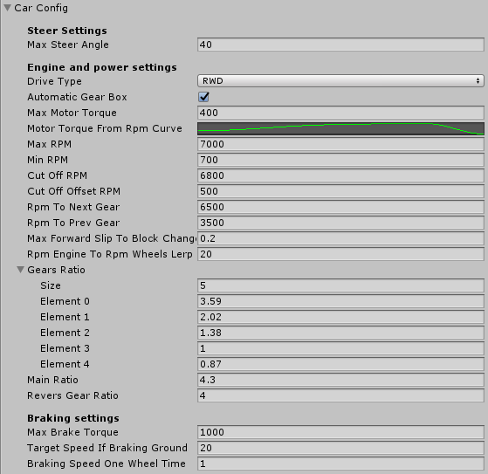

Max steer angle: the max angle at which the front wheels turn.

Power settings: Settings for the engine and gearbox simulation. I wanted that all settings were close to reality.

AutomaticGearBox: TODO It is necessary to implement a manual gear shift, now only the automatic gearbox works.

MaxMotorTorque: Torque issued by the engine in max point, without multiplier gears ratio.

MotorTorqueFromRpmCurve :

By horizontal axis the current engine rpm x1000.

By vertical axis the current motor torque multiplier (1 is max, 0 is min).

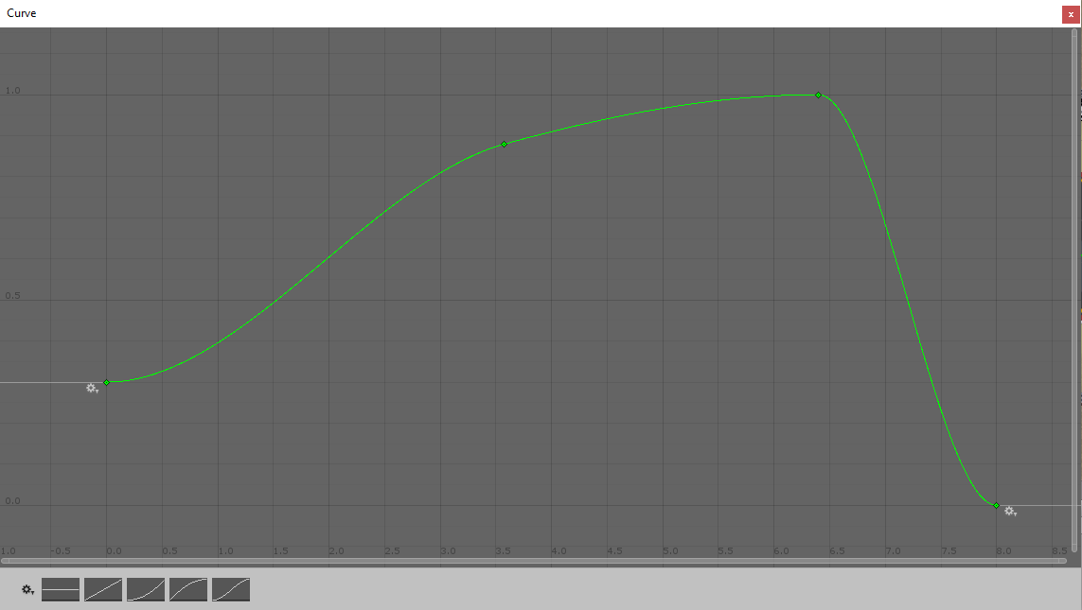

MaxRPM: Max rpm for engine.

MinRPM: Min rpm for engine.

CutOffRPM: RPM on which the cut-off works.

CutOffOffsetRPM: The count of RPM lost during the cut-off.

RpmToNextGear: RPM at which the next gear is change, if the wheels do not forward slip.

RpmToPrevGear: RPM at which the previous gear is change, if the wheels do not forward slip.

MaxForwardSlipToBlockChangeGear: Max forward slip at which gear shifts are possible.

RpmEngineToRpmWheelsSpeed: The speed of change of engine speed.

GearsRatio, MainRatio, ReversGearRatio: Gear ratios of the gearbox. All data is taken from the documentation for the car's gearbox.

MaxBrakeTorque: Max brake torque.

TargetSpeedIfBrakingGround: The car stops to this speed when driving on the braking ground.

BrakingSpeedOneWheelTime: Braking speed with one wheel on the braking ground.

To use cars with CarController separately from everything, you need to add the prefab of the car to the scene, add the UserControl component to this prefab, add the AudioListiner to the car to listen to the sounds, add a camera to the scene and specify a link to the managed car in CameraController.OverrideCar.

# AI Control

RegimeSettings

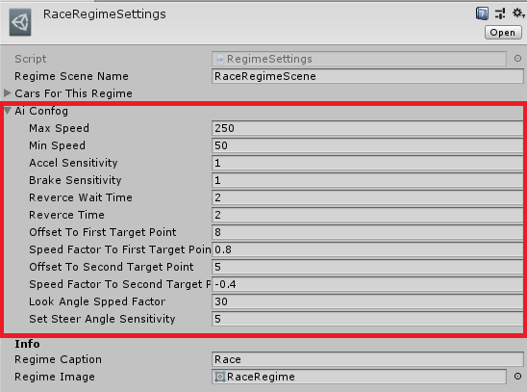

The bots are configured in the "AI Сonfig". For all cars one config is suitable. For each regime, you can configure unique AI behavior.

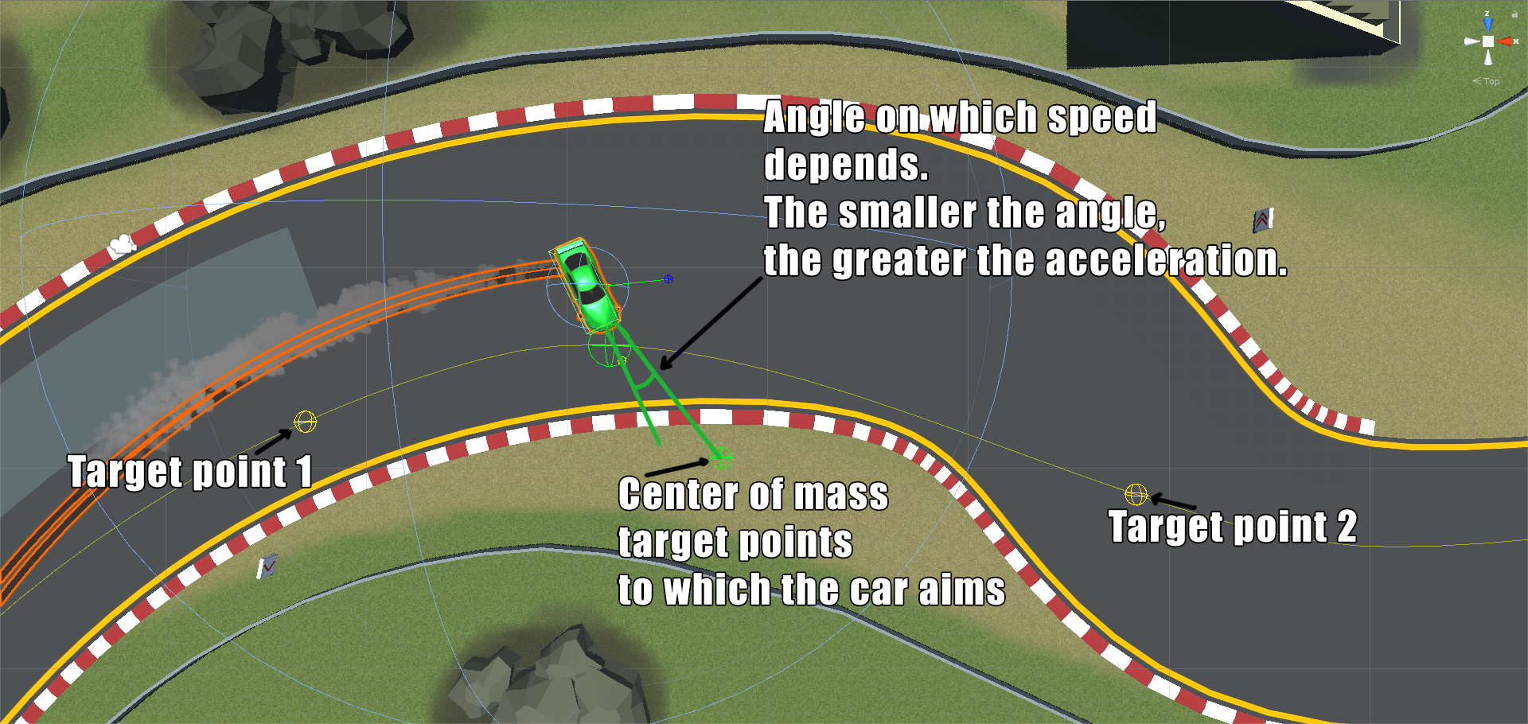

Bot always aim to the center of mass. Acceleration is calculated based on the angle to the center of mass.

# Balance settings

The project uses a convenient balance system. The desired value can be accessed from any part of the code.

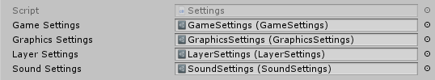

Settings: This asset is loaded from resources. It contains links to other assets of settings. For what the fields in assets are commented out in the code. The hierarchy of assets has already been met earlier, in the section "Project flow chart".

It is also possible to limit the speed for AI, using the LimitSpeedTriggerZone component, when hit on a trigger with this component, the AI ​​will begin to slow down to the speed specified in the setting. Restriction zones are in the PortForRace scene object SpeedLimitsForAI.

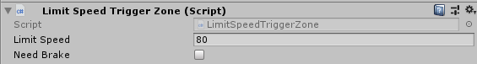

NeedBrake: When the flag is set, AI will slow down with braking in this zone to the desired speed.

# Split level loading

The level is loaded from 2 scenes. The 1st scene of the level, it contains objects of level geometry, a game controller, and an effect controller that are unique for the level. The 2nd scene for the regime, on it is the UI.

The name of the scene level is indicated in the level asset:

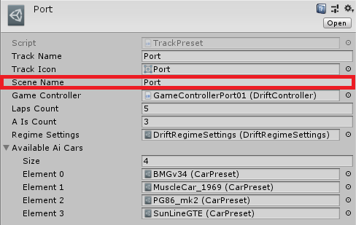

The name of the scene regime is indicated in the RegimeSettings asset.

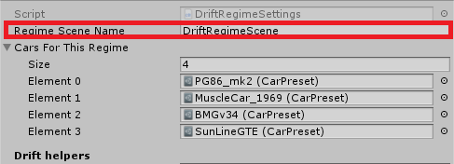

# How to create a track

Auto add method ([Video instruction](https://youtu.be/kMov5Vo3Qmo)):

The track can be easily added using the window "Window/Arcade Car Controller (ACC)/Create track"

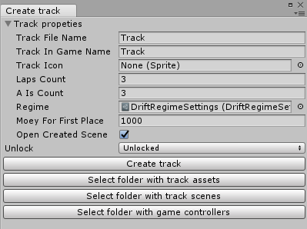

TrackFileName: All track files will be created with this name.

TrackInGameName: The name of the track that will be displayed in the game (Menu etc.).

Unlock: A way to unlock a track.

After setting all the parameters, you need to click the "Create track" button, after which all the necessary files will be created. After creating the track, you can edit the created scene.

"Select folder ..." buttons are needed to search for folders in which files are created.

All default settings and file saving paths are in the CreateHelperSettings asset.

Manual way to add:

Level scene.

On the scene level must be present:

Level geometry with colliders.

GameController, with start car positions, positioning system, countdown and EndGameTimer (To complete the multiplayer game).

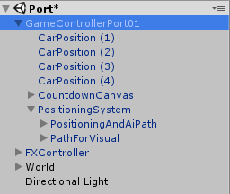

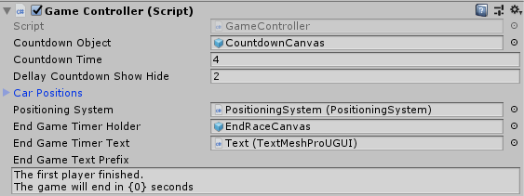

FXController, is now used for all levels one prefab, if necessary, it can be changed.

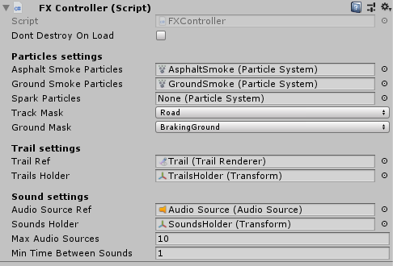

Track preset.

This asset contains all the necessary configuration for loading the level.

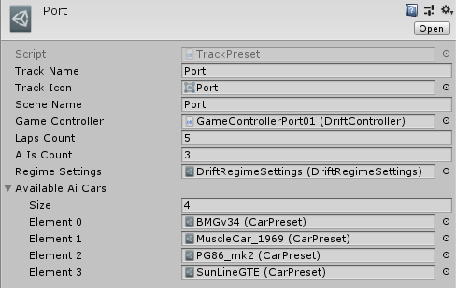

Track Name: The name of the track displayed in the track selection menu.

Track Icon: The icon of the track displayed in the track selection menu.

Scene Name: Loaded Scene name.

GameController: Link to prefab GameController track.

Regime Settings: Link to the regime to load an extra scene.

Available Ai Cars: Cars available for AI of this track.

TrackPreset have unlock logic, field “Lock Type”.

Assets are created from the context menu "Create/GameBalance/Game/TrackPreset". Or you can duplicate the existing one.

After creating a link to an asset you need to put in the lists "GameSettings/Tracks" and "MultiplayerSettings/AvailableTracksForMultiplayer".

# Positioning System

Positioning system To cancel scoring in the wrong direction and to control circles. PathForVisual is needed to display the track map in the track selection menu, later it will still be used for the mini map.

Positioning system settings.

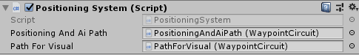

Waypoints

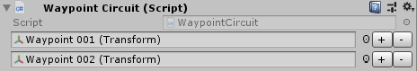

….

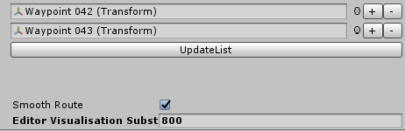

WaypointCircuit is the way to go. To add items, click the "+" button or add an empty child object and click the button "UpdateList".

WaypointCircuit.cs taken and modified from “Standard Assets”. Now works only for the circle. After a few updates will be the ability to select a segment with a start and finish.

At the first level premiere, the path is yellow. The path must lie on the optimal trajectory. 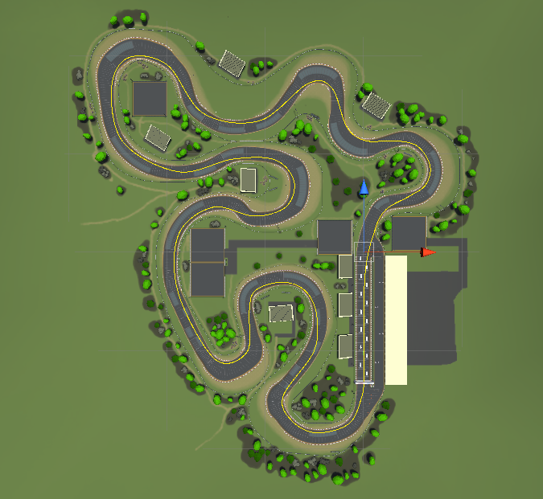

!!!Attention!!! The first and last points must have the same coordinates at the finish point in order to correctly count the laps.

# Main menu and game menu.

The size and functionality of all elements is designed for a mobile platform.

All windows in the game have animations and have a standard animator.

Settings window. In main menu and in game menu.

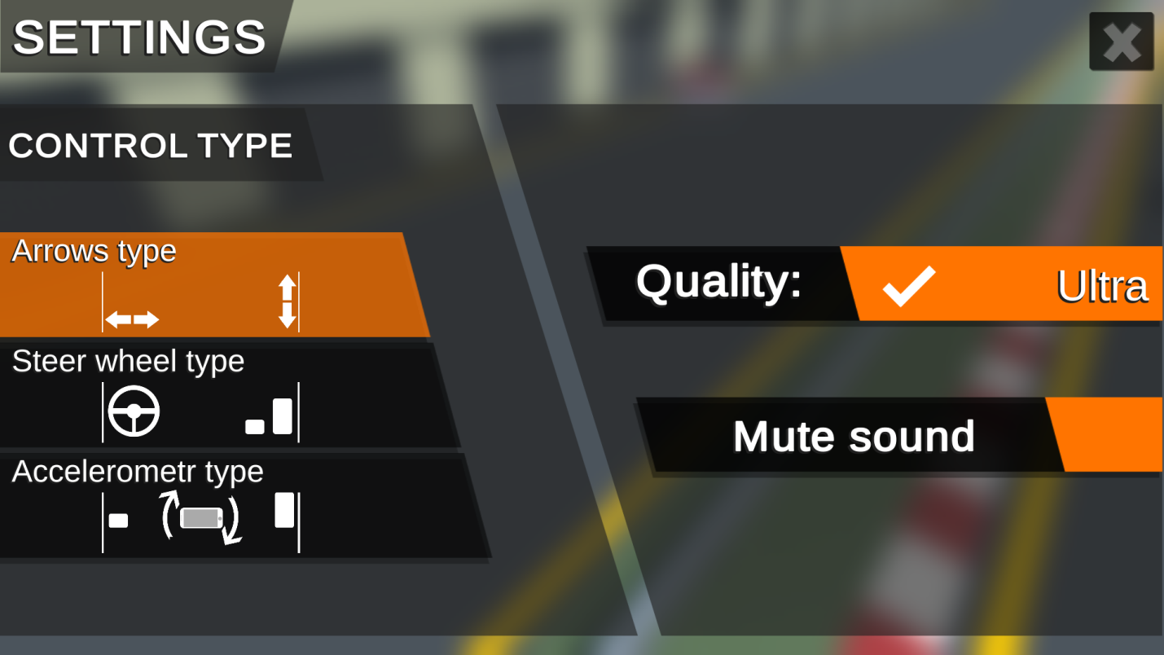

In the left part of the settings, you can select the type of control. The selected type is not available for re-selection. Arrows is selected by default. The right side is settings graphics quality and mute the sound.

Select car window:

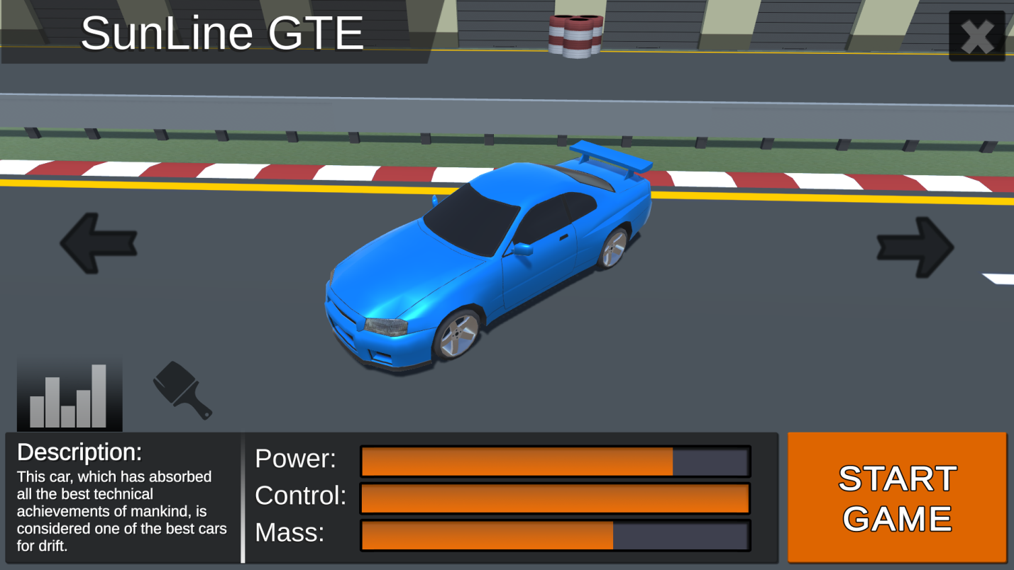

At the bottom of the parameters of the car. The maximum value is selected among all available cars.

End game window for Drift regime.

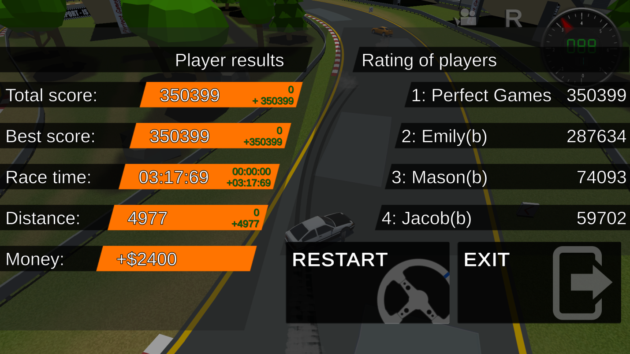

End game window for Race regime.

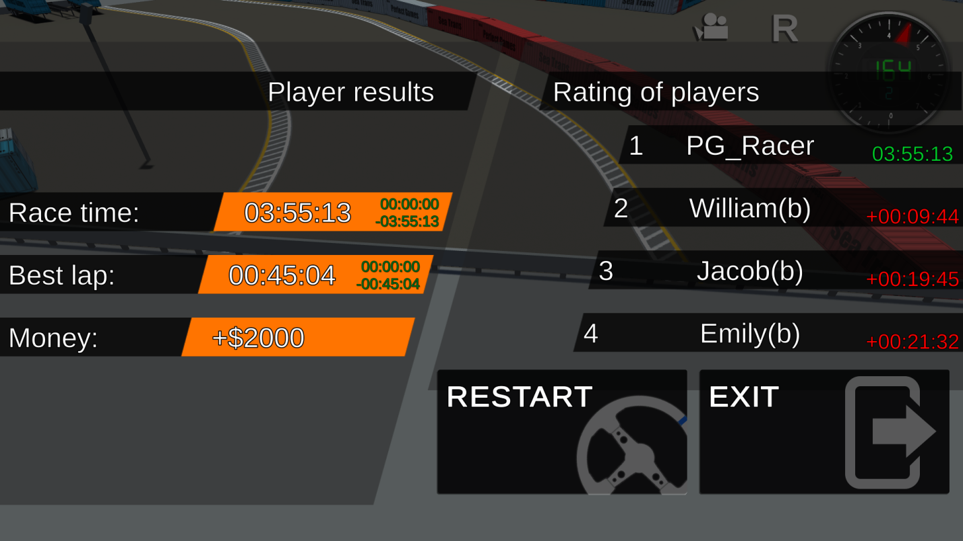

The left side indicates the player’s results and the cash prize for the race. On the right side is a table of players with points or race time. The window for ending the game for each regime is its own, located on the scene specified in the regime settings.

# In race UI

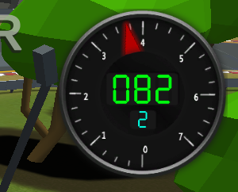

Speedometer, tachometer, current gear. Used for all modes, located in prefab CarStateCanvas, CarStateUI component.

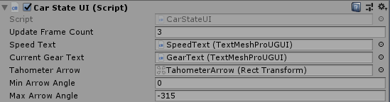

Drift indicator. The left side displays the scored points and the bar start / gain points. The current multiplier and the progress bar to the next multiplier are displayed on the right side (Maximum multiplier is 9, configured in DriftRegimeSettings). The indicator is reflected only in drift regime.

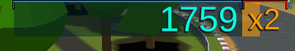

Race regime statistics:

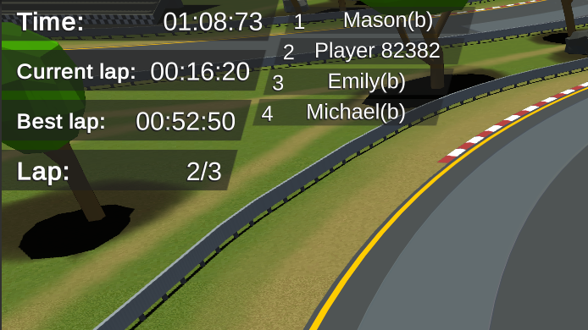

Drift regime statistics

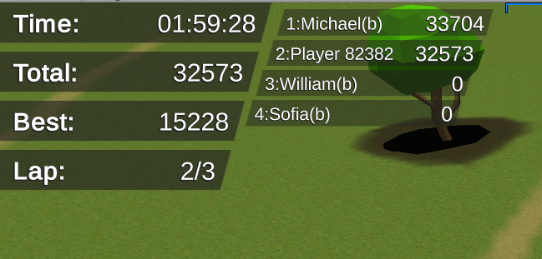

# Shader: AlphaColorMask

Fields:

Color - Mixing color.

Albedo (RGBA) – Map with base color with alpha. In a pixel with transparency 0, color is taken only from the texture, where alpha 1 color of the texture is mixed with the color of the material.

Metalic (RGBA) – Map metallic and Smoothness. The Smoothness is taken from the map where the alpha of the main color is 0. Where the alpha of the main color is 1 the Smoothness is taken from the Smoothness field.

Preparing texture is easiest with Adobe Photoshop. Simply using a mask hides those places that would not like to paint with the help of color from the material.

Shader: AlphaColorMaskSmoothnessFromMetalic

It has all the same fields, except for the field of Smoothness, Smoothness is taken from the map Metalic (RGBA).

SetInstancingMaterialFields.cs:

Sets the parameters of color and Smoothness at start. Without affecting the base material.

# Mesh Painter

Additional script .

In this project, I needed the functionality of the terrain, but its use is too bad for the performance on weak devices. I decided to make a version with the ability to draw on the mesh with the desired texture. The MeshPainter script is used only in the editor to change the control texture, only the shader is used in the game.

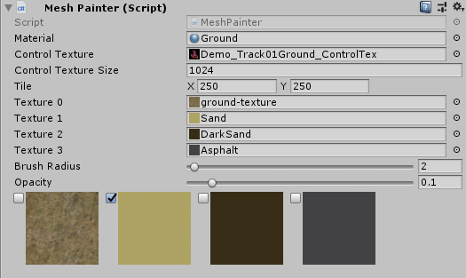

Material: For each object of type MeshPainter need your own material of type Custom/MultiTextures.

Control Texture: It is created automatically if there is no reference to an existing texture in the field. It has 4 channels (A, R, G, B). Each channel is responsible for its texture from the list below.

Tile: Tile all textures from the list below.

Texture0,1,2,3: The textures needed for drawing. By default, the entire mesh is colored with the first texture.

Brush Radius and Opacity: Settings of brush.

Toggles with textures: To select the current texture as a drawing. When you select a texture, the drawing mode in the scene is turned on, now you can draw only on the selected object, other objects from the scene view cannot be selected, only in the hierarchy. When changing the texture or selecting another object, the texture is preserved.

# Update history.

Update 1.0.1

Changed the main car to a more detailed model.

Fixed bugs when importing asset into higher versions of unity.

Update 1.1.0

Added main menu and game menu.

Added 3 new cars.

Changed WheelColliders balance. Now the gameplay has become much more dynamic.

Slightly changed the structure of the project, preparation for the introduction of AI.

Added save/load settings and player results.

Improved imitation of gearbox (now it is not twitching and does not jump through the gear).

Fixed minor bugs.

Update 1.2.0

Added AI control for drift regime.

Added the ability to select colors for cars.

Redesigned user interface.

Fully redone positioning system.

Small fixes in the style of the code, for more convenient reading.

Minor bugs fixed.

Update 1.2.1

Improved control (tilt control) for mobile devices.

Update 1.2.2

Added backfire effect.

Update 1.2.3

Improved control (Steer wheel control) for mobile devices.

Update 1.2.5

Physics and graphics optimization of for mobile devices.

Update 1.3.0

Added new track (Port).

Added select menu for tracks.

Slightly improved imitation gearbox.

Changed loading logic level.

Fixed small bugs.

Update 1.3.1

Added “Enable AI” option in the game settings.

Update 1.3.2

Added in-game store and content unlock logic.

Minor bugs fixed.

Branch Multiplayer 1.0.0

Added multiplayer.

Update 1.5.0

Added a new regime "Standard Racing".

A convenient setting for the wheel collider has been added.

Added support for the Xbox controller.

Change in drift regime: Now the cars have more dynamic behavior (The old behavior settings are in the asset, the documentation describes how to use them).

Improved AI behavior. One AI is used for all modes with different settings.

Improved positioning system.

Bugs fixed.

# Contacts

On all questions you can contact by e-mail:

Discord :

[#perfect-games](https://discord.gg/REZJNf9)

e-mail:

[Bugrov1990@gmail.com](mailto:Bugrov1990@gmail.com)

[Bugrov1990@mail.ru](mailto:Bugrov1990@mail.ru)

[war.90@mail.ru](mailto:war.90@mail.ru)